***NFC Cup Game***

Introduction

This tutorial will demonstrate App Inventor's Near Field Communication (NFC) capabilities. You'll build an application that will simulate the shell game by writing messages to NFC tags in setup mode and reading them in play mode. In order to get the full experience from this application, you will need to purchase readable, writable, NFC tags.

IMPORTANT: Applications built with the NFC component will not respond to tags while in live development mode. To test your application, you must build your app and download the APK to your phone. (How do I build an APK?)

Getting Started

Go to the App Inventor website, begin a new project titled 'BallShuffle', and connect your phone. Download the following images onto your computer and upload them into your project. (Right-click or ctrl-click and choose Save Image. Remember where you put them!)

Ping Pong Ball Image

Question Mark Image

Red Cup Image

Set up the Components

The user interface will consist of a menu at the top that lets you switch between the “setup” and “play” modes, a menu that will appear during setup mode and disappear during play mode, and in image that will change based on NFC input and output.

Component Type Palette Group What You'll Name It Purpose of Component Component Settings

Label User Interface MainMenuLabel Title bar for main menu Text: Main Menu; Font: Bold; Fontsize: 16

HorizontalArrangement Layout MainMenuArrangement Line up two "mode" buttons side by side Width: Fill Parent; Height: Automatic

Button User Interface SetupModeButton Change to setup mode Text: Setup; Width: Fill Parent

Button User Interface PlayModeButton Change to play mode Text: Play; Width: Fill Parent

VerticalArrangement Layout SetupArrangement Width: Fill Parent; Height: Fill Parent

VerticalArrangement Layout SetupMenuArrangement Line up the setup menu options Width: Fill Parent; Height: Fill Parent

Label User Interface SetupMenuLabel Title bar for setup menu Text: SetupMenu; Font: Bold

HorizontalArrangement Layout SetupButtonArrangement Hold the buttons for setup menu Width: Fill Parent; Height: Fill Parent

Button User Interface BallButton Lets user define NFC tag as "ball" Text: Ball; Width: Fill Parent

Button User Interface CupButton Lets user define NFC tag as "cup" Text: Cup; Width: Fill Parent

Label User Interface InstructionLabel Give the user instructions for the mode they are in Text: -; Width: Fill Parent

Image User Interface Image1 Place holder for images Height: 200 pixels; Width: Fill Parent; Picture: questionmark.png

Horizontal Arrangement Layout ImageArrangement Allows you to center the image AlignHorizontal: Center; Width: Fill Parent;

Label User Interface ResultsLabel Show results of user's actions Text: -; Width: Fill Parent

NearField Sensors NearField1 Gives access to NFC capabilities ReadMode: checked;

Add Behaviors to the Components

We're going to build all of the menus and make the menus work, then we'll modify them to incorperate the NearField component.

To start, we're going to create several variables to make it easier to reference text that will be reused throughout the application:

Next we're going to define the initialization behavior and define the button behavior:

When the screen is initialized, we want the app to display the question mark picture and the setup instructions. Since the SetupMenuArrangement is initially set to visible, we don't have to address it in the Screen1.Initialize block. When the user clicks on the SetupModeButton or on the PlayModeButton, then we want to change the SetupMenuArrangement to visible or invisible respectively. In addition, when the user clicks one of these two buttons, we want to make sure that the correct instructions for that mode is displayed and that the image resets to the question mark picture. When the user clicks on BallButton, we want the image to a change picture of the ball and the CupButton should change the image to a picture of the cup.

The blocks should look like the image below and the buttons should correctly toggle all of the images

Now that the interface works correctly, we're going to add the NFC functionality to the app. We're going to modify the 5 blocks by adding the correct NFC behavior to each one. This will make the buttons turn on read mode when the

Now, we define the app's behavior when a tag is written. When the app writes a tag, we want the the instructions to update, we want the picture to reset, and we want to change NearField1.ReadMode to true so that the tag isn't accidentally overwritten.

here is a full file...

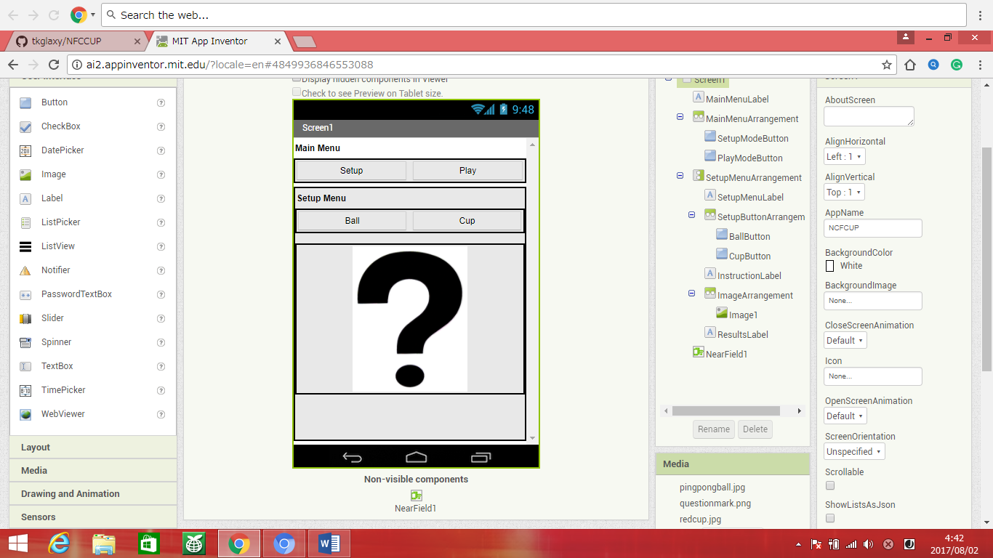

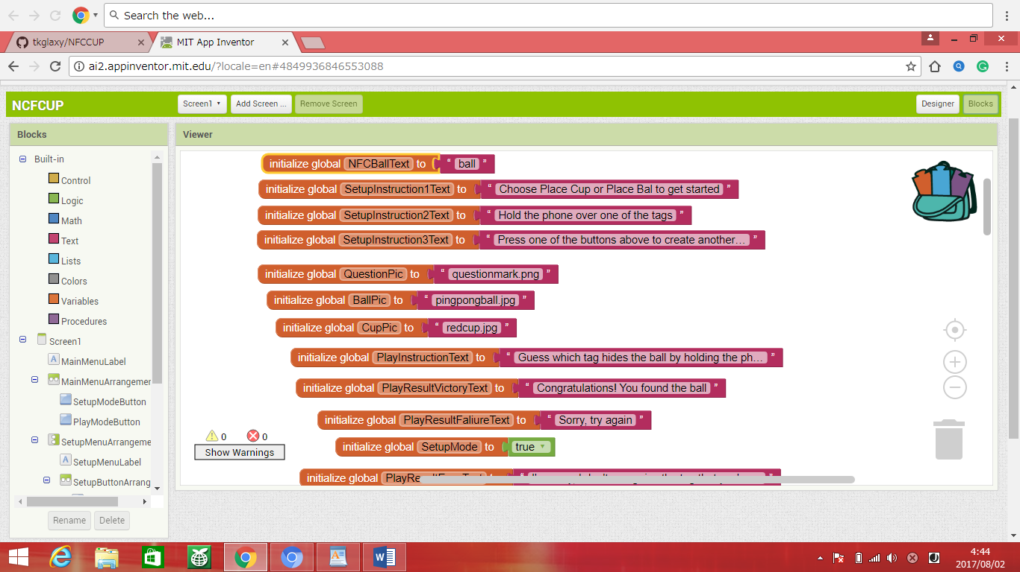

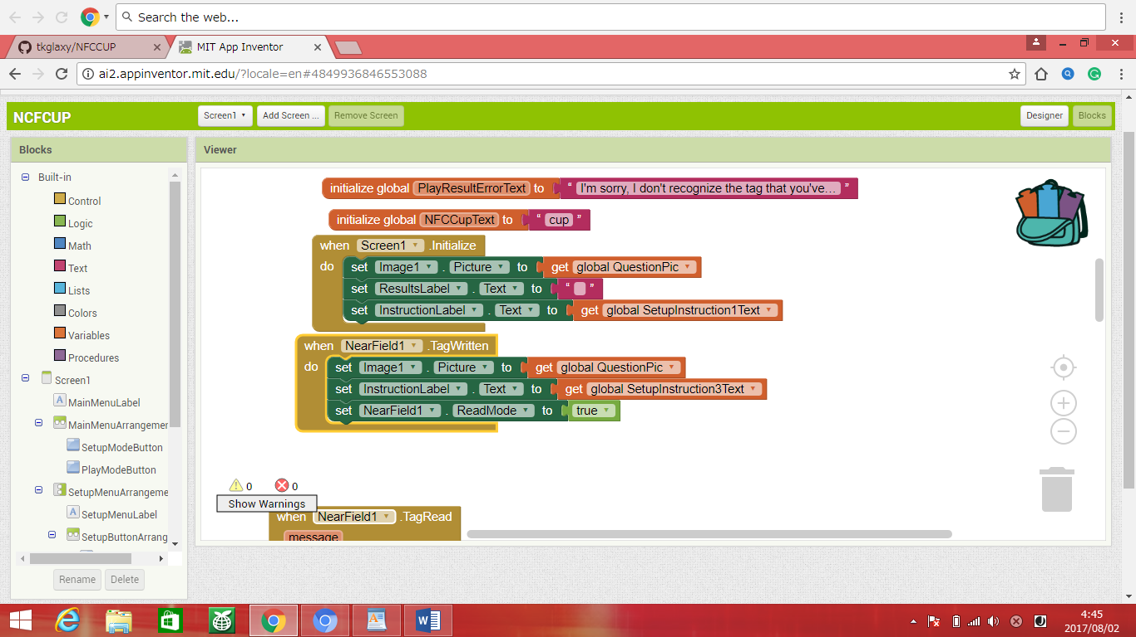

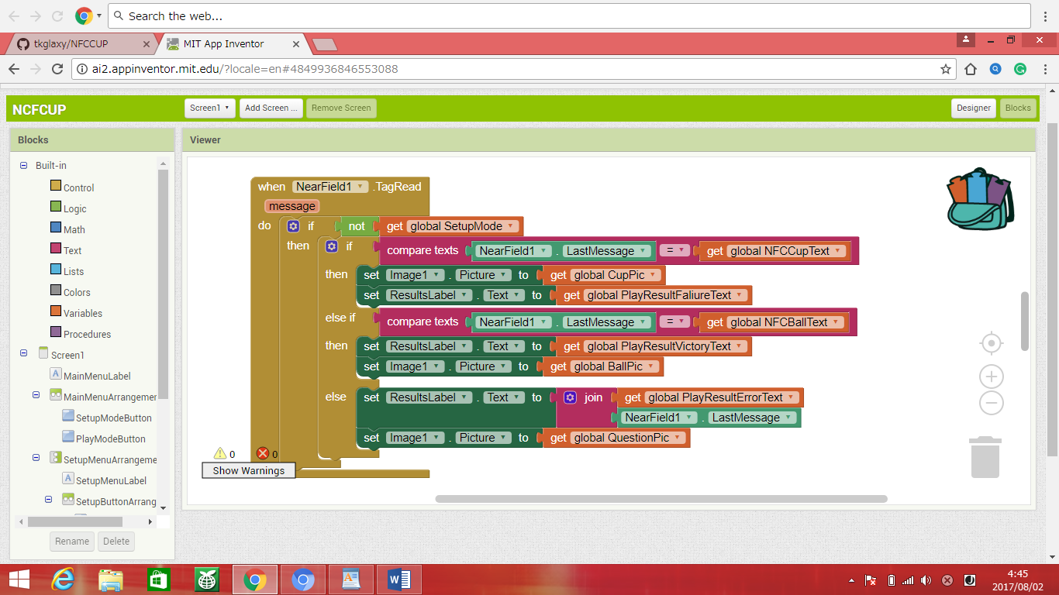

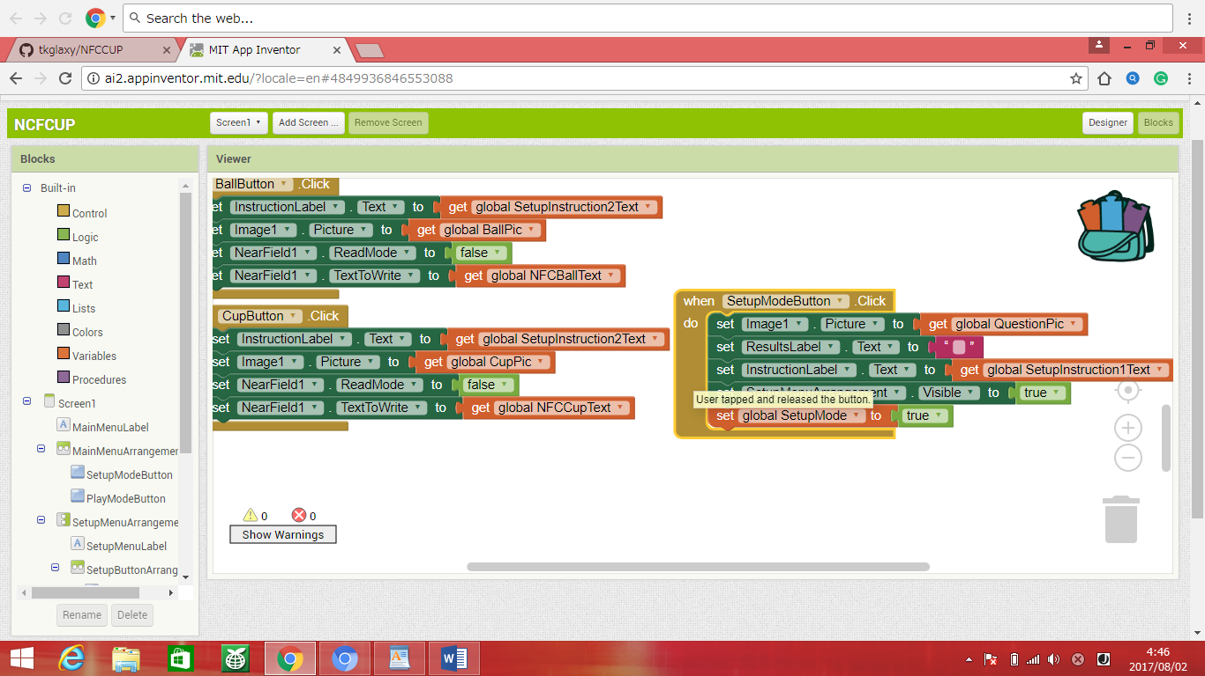

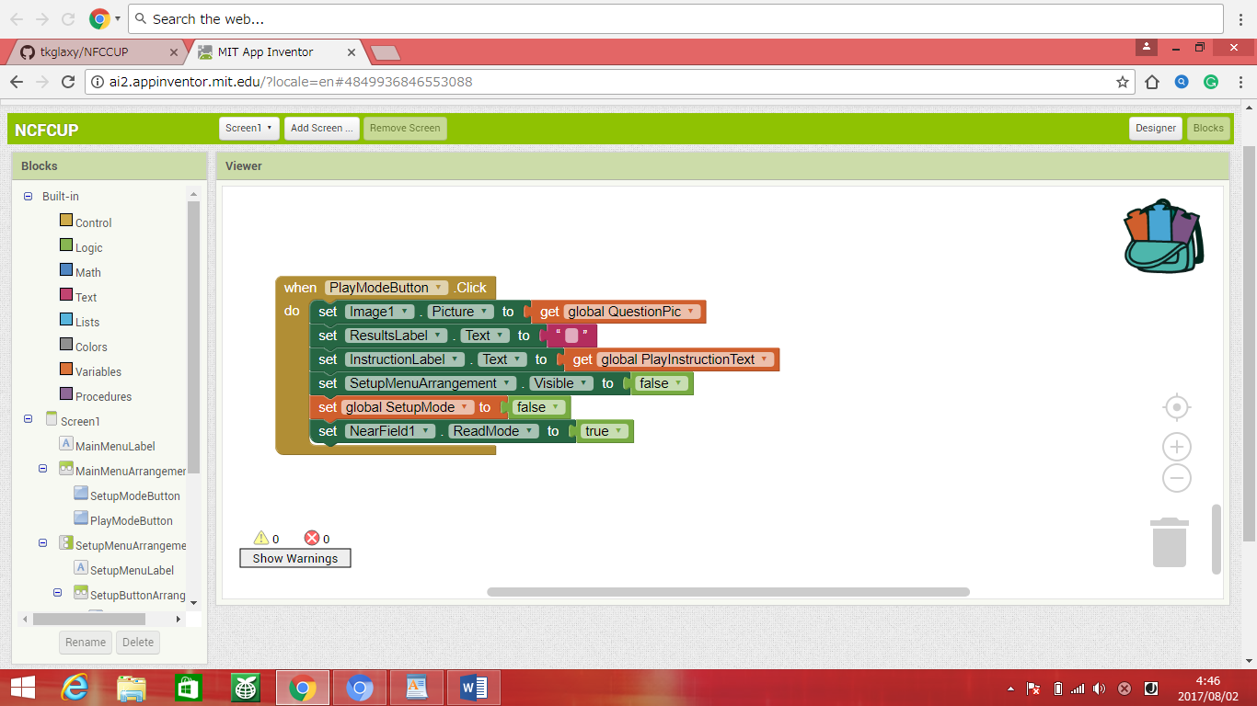

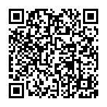QR　 Code for file.